**Blue Monkey Tea Design Guide Instructions**

***Instructions:*** *You will create your own design guide for the new Blue Monkey Tea website. We want you, as the web designer, to be as creative as you wish. The only guideline is that the tone of the website must be appropriate for a tea shop. All we ask is that you document your process and follow your own design guide. The purpose of the guide is to give future designers the ability to pick up where you leave off and continue your work. Please refer to the supporting files for an example of what we want to see in your design guide. Here are some tips for preparing your design guide.*

**Logo**

You are welcome to use our existing logo or create a new one and include it in your design guide.

­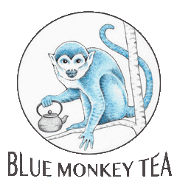

**Colors**

We want you to choose the main colors that will make up your website and include it in your design guide. If you have trouble coming up with your own color combinations, please consider the following resources:

<https://coolors.co/>

<https://color.adobe.com/create>

<https://paletton.com/>

<https://www.canva.com/colors/color-palette-generator/>

**Fonts**

We encourage you to stylize creatively with clear, readable, and accessible fonts. We recommend Google web fonts for compatibility across browsers. Below are a few recommendations:

Roboto

Open Sans

Nova Lato­

PT Sans

Oswald

Please include samples in your design guide of how you will use fonts for the following elements:

Title

Subtitle

Heading 1

Heading 2

Heading 3

Heading 4

Body Text

Bulleted Point